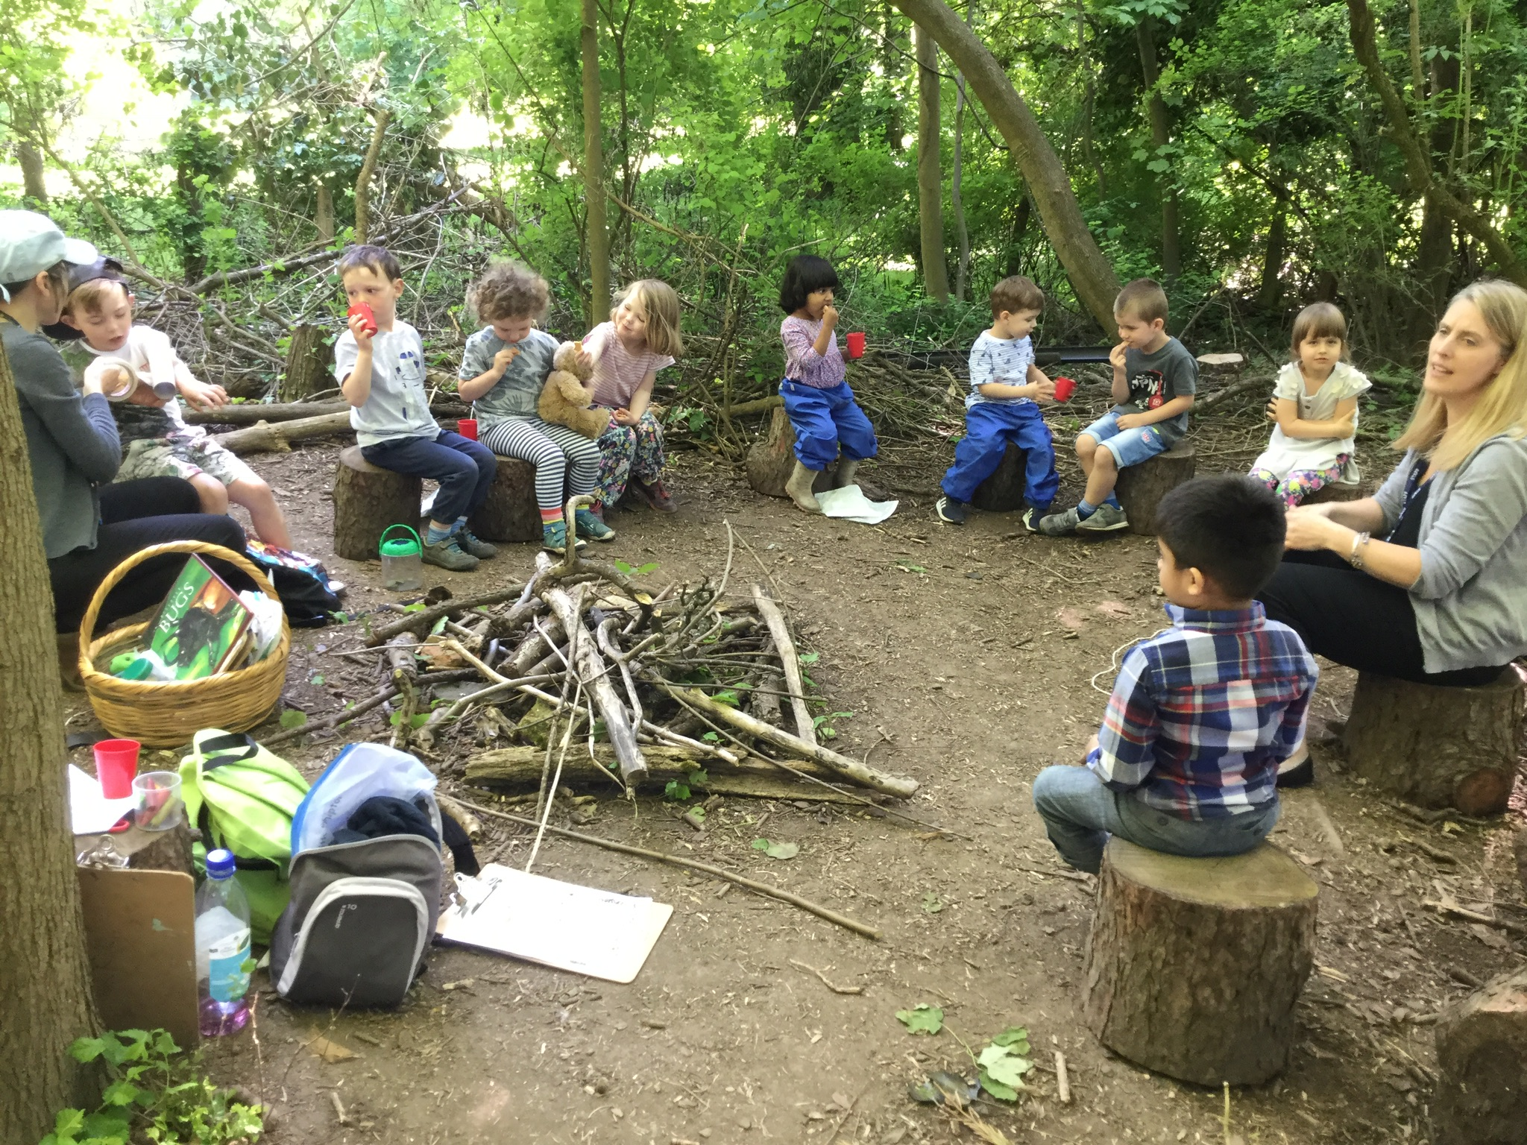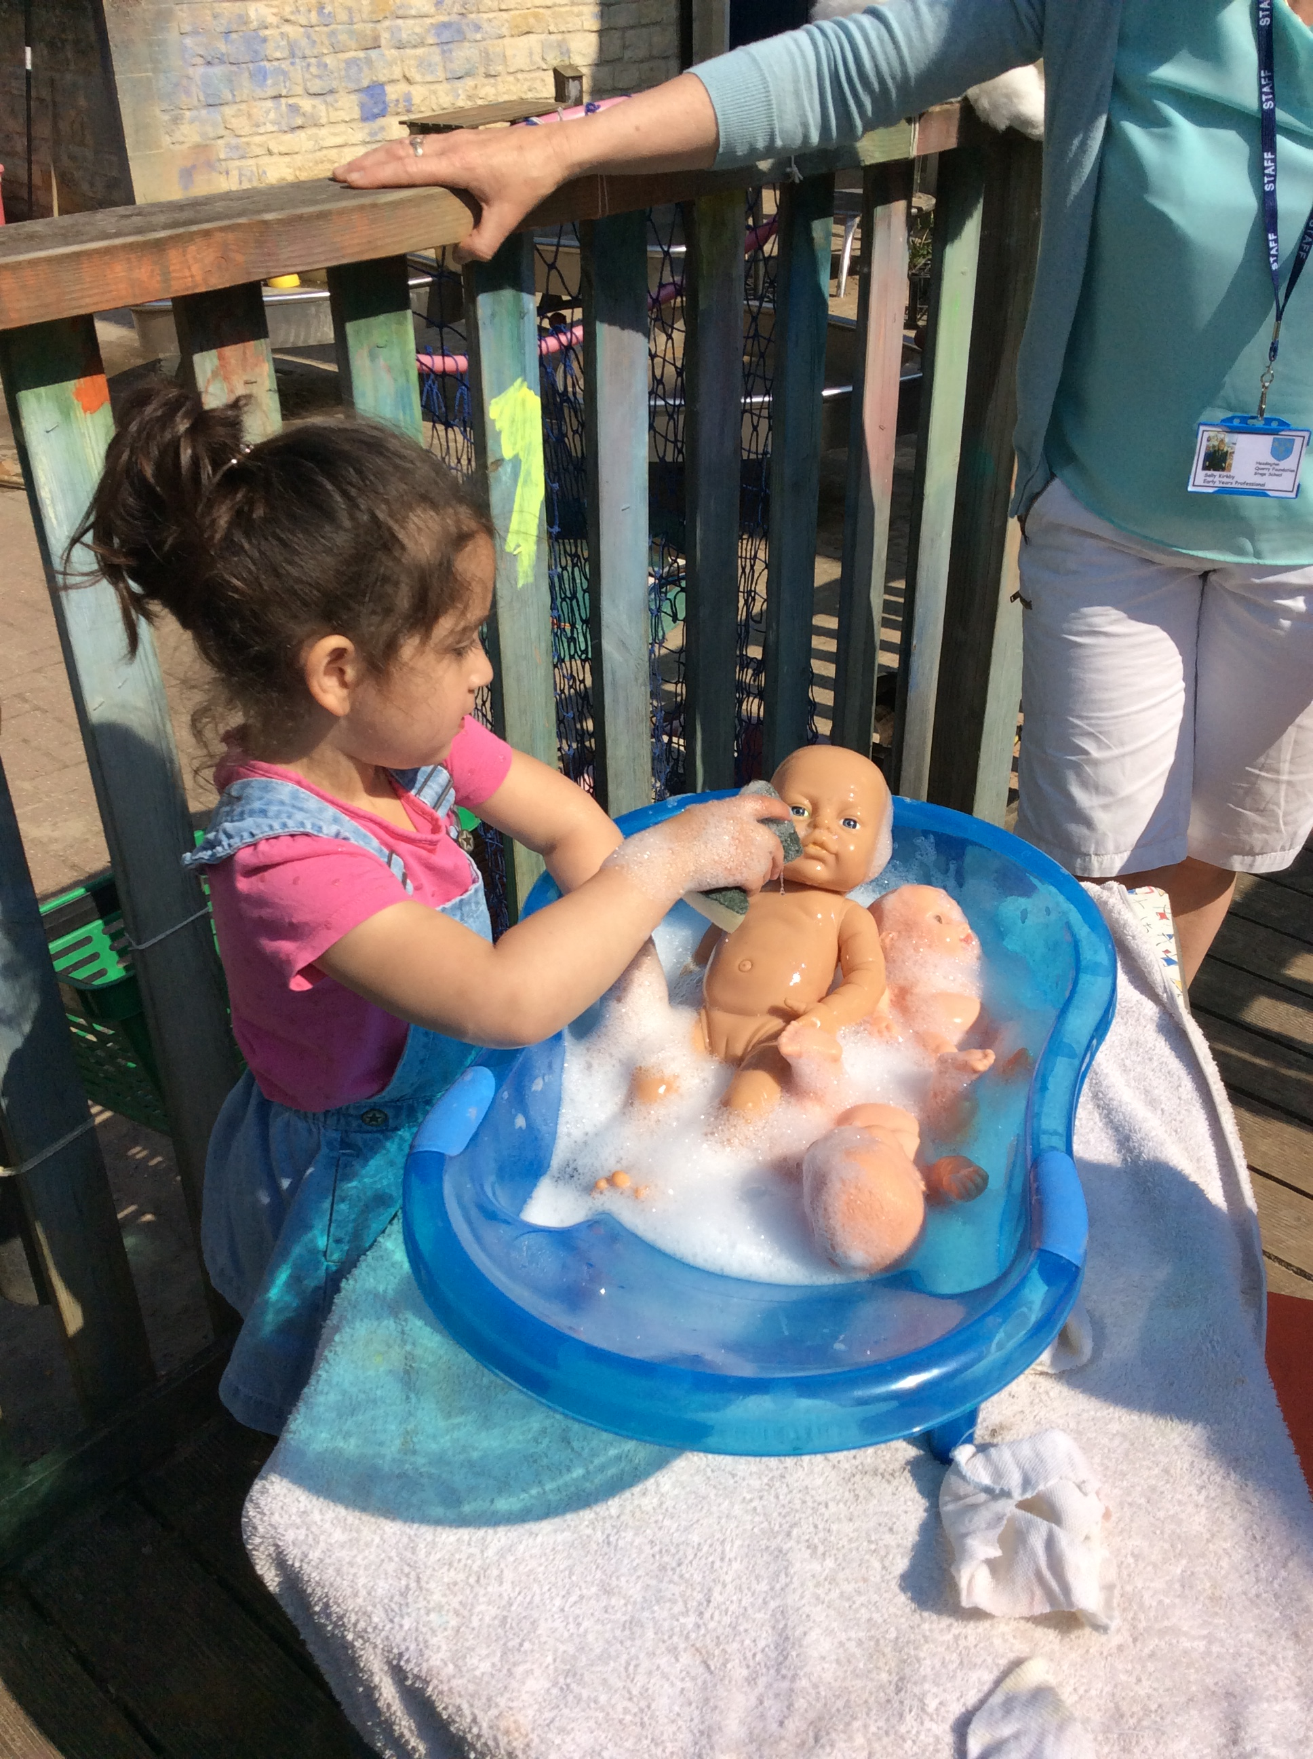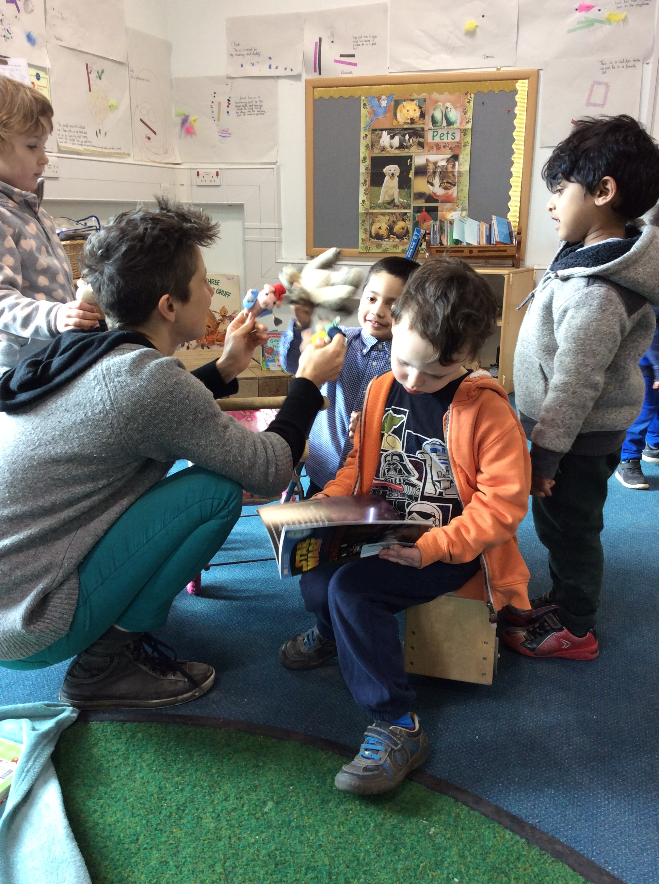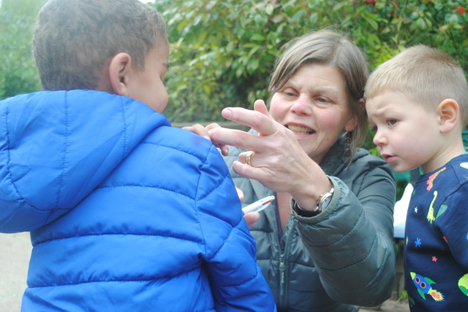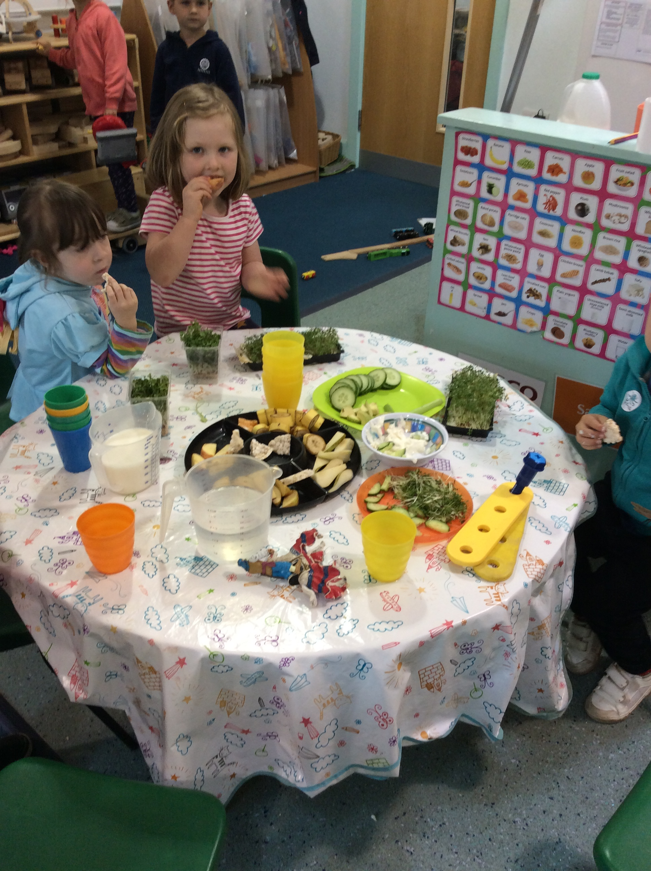

***Our children enjoy freedom and choice. They choose their snack and vote for their favourite songs and stories. Children choose what they play, where they play and who they play with.***

**Children have hands on learning experiences of other cultures and religions. Toys reenact a variety of ethnicities and cultures. We teach children to treat others, as they would like to be treated. We learn to be part of the school community.**

Democracy

## **Fundamental British Values at Headington Quarry**

Children learn to follow the rules to keep themselves safe. Children take responsibility to look after and tidy up the nursery. Children participate in group sessions and learn to listen to each other and wait their turn. They learn to share and be fair. They learn good manners are important.

Rule of Law

Individual Liberty

Mutual respect and Tolerance

A consistent routine supports children to develop independence. Children develop close relationships with other children and adults. The adults support children to work through their emotions and they learn skills to resolve conflict in a positive way.

# Mauris ante urna, congue in, venenatis eu, dictum vel, justo. Donec neque. Nam tincidunt leo a nisi placerat congue. Sed nonummy, diam non ornare auctor, enim elit commodo ipsum, in dapibus pede nisl nec urna. Donec dictum facilisis turpis. Donec quis ipsum. Maecenas quis odio eu erat lacinia sodales.

Pellentesque vitae risus. Pellentesque tempus tellus a mauris. Nulla facilisi