|  |  |  |  |
| --- | --- | --- | --- |
|  |  |  |  |

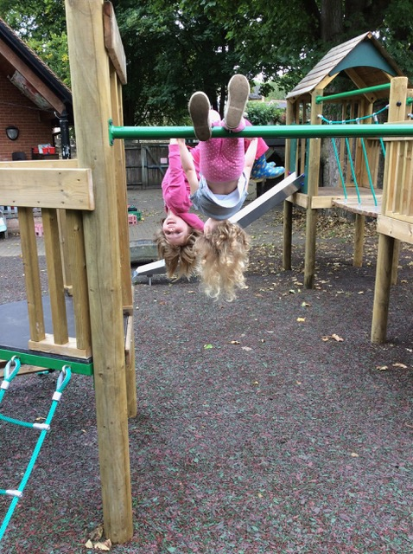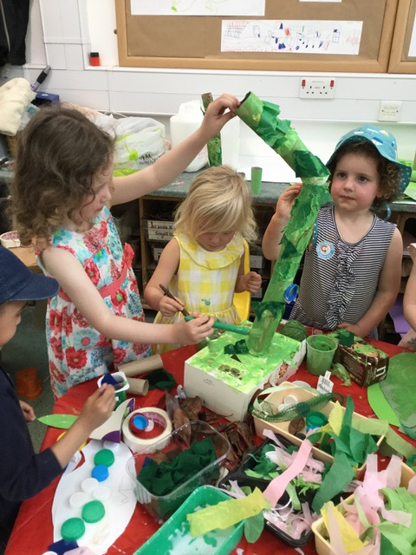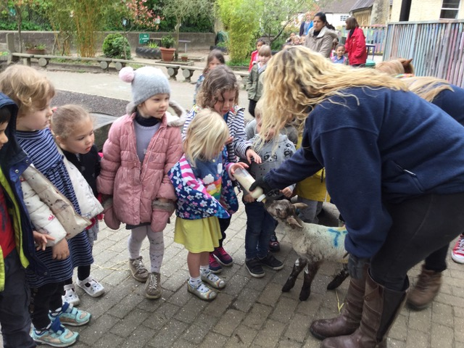

Dear Parents

I am delighted to introduce the annual report on behalf of the governors of HQFSS, giving an overview of the governing body’s role in the continuing development and success of the school. Despite a climate of increasing financial pressure for nursery schools we have made exciting changes this year including offering 30 hours provision and developing a new forest school site. The flourishing children demonstrate how special and important our nursery school is.

Katherine Bull

Chair

Katherine Bull

Chair of Governors

Katherine Bull, Chair of Governors



Headington Quarry Foundation Stage School

Governors’ report to Parents 2018

[www.](http://www.sladeandheadingtonchildrenscentre.org.uk)headingtonquarry-nursery.org.uk

Curriculum

Governors from the Curriculum Committee have met on a regular basis to discuss action points for improvement, monitor children’s progress and outcomes and celebrate the strengths of the practice and provision across all areas of learning.

All governors have engaged in monitoring the curriculum through reports provided by the Headteacher. These have included an analysis of children’s progress from their starting points.

Each term the Headteacher and staff team members scrutinise the progress of both individual children and groups for example, Gender, EAL etc. This information is used to inform teachers planning so that they can best provide for children’s next steps.

Governors have also engaged in visiting to observe the curriculum in action in the nursery both indoors and outside. This year they have focused on provision for EAL learners, Literacy and Personal and Social aspects of learning. New governors are offered in house training in Early Years Development Matters.

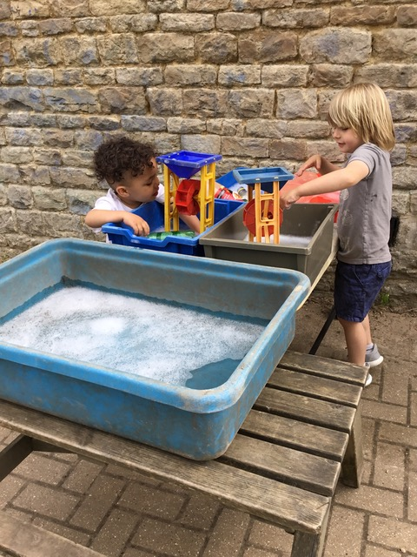

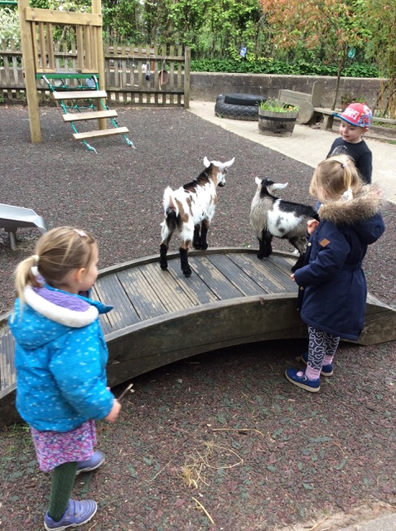

Finances

A key area of responsibility for the governing body is setting and approving the school budget and development plans; with the Leadership & Management committee responsible for financial monitoring of these plans.

The income statement for the year shows a small surplus at the end of 2017/2018 financial year which has been achieved by increasing the number of 30 hours children attending the school during 2018 (January to July). There are carry over funds currently available to support the school in the short-term, however they reduce each year. Discussions are being held with OCC regarding funding for Nursery Schools with the aim of securing the school’s financial sustainability. Currently, the funding rules regularly change often involving a reduction in funding.

Towards the end of the financial year the catering supplier was replaced achieving cost savings. We continue to receive a financial contribution from St Andrews Primary School to cover overhead costs.

Day care also supports the school with a financial contribution to its funds. The PTA have provided fantastic support to the school through successful fund-raising events. Governors have claimed no personal expenses this year.

Inclusion & SEND

(Special Educational Needs and Disability)

HQFSS is an inclusive nursery and foundation stage school that welcomes all children and their families. We cater for a wide age range, and are

aware that the children are at varied stages of development and have differing interests. Staff members plan the sessions so as to provide

support for all the children, and challenge them accordingly. If a child is identified as requiring extra support, s/he will receive attention from skilled staff members. We work in partnership with parents along with external professionals, where appropriate, to ensure childrens needs are met. Governors regularly monitor our SEND policy and ensure that it is implemented. Annie Arnold, Foundation Stage Teacher, is our SEND Co-ordinator.

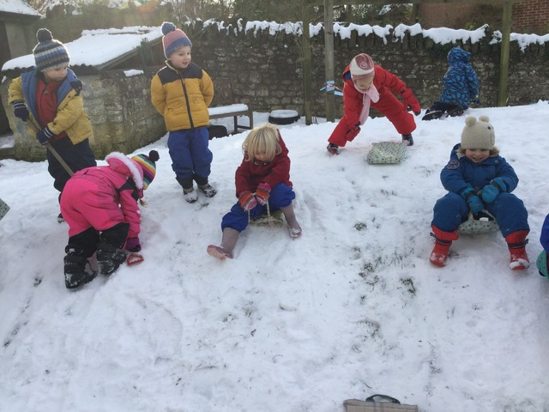

| **Name** | **Govenor category** | **Committees** |
| --- | --- | --- |
| Natalie Wilson | Headteacher  Ex officio | Leadership and Management, St Andrews Steering Group, Premises, Health & Safety, Family and Community |
| Katherine Bull | Chair of Governing Body  Co-opted Governor | Safeguarding Governor, Leadership and Management, Headteacher Appraisal Panel |
| Cllr Roz Smith | LA Governor | Safeguarding Governor lead, Premises, Health & Safety Governor, |
| Lisa Crook | Co-opted Governor | Family and Community Chair, Premises, Health & Safety Governor, |
| Theresa Broad | Co-opted Governor | Curriculum Chair |
| David Knight | LA Governor | Premises, Health & Safety Governor Chair, Headteacher Appraisal Panel |
| Heather Stanbury | Vice Chair of Governing Body Parent Governor | Leadership and Management Chair, Headteacher Appraisal Panel,  Safer Recruitment Governor |
| Peter Williams | Parent Governor | SEND Governor lead |
| Paul Naish | Parent Governor | Leadership and Management |
| Duncan Anderson | Co-opted Governor | Curriculum, St Andrews Link Governor, St Andrews Steering Group |
| Susannah Murphy | Associate Member | Curriculum |
| Jane Barnes | Staff Governor | Family and Community |
| Kelly Welch  Accessibility  As part of the school's Disability Equality Scheme the governors make it a priority to regularly review our Accessibility Plan and our provision for disabled users of the school. The Nursery is accessible for all users. There is a ramp at the children's entrance, a toilet accessible to wheelchair users and a designated disabled car space. At HQFSS we are committed to ensuring equality of education and opportunity for all pupils, staff, governors and families involved in the school community, in a healthy and safe environment. We welcome all children and want them to participate fully in school life. Prior to starting at the school we meet parents to plan appropriate provision. The school responds to the needs that children may have, installing any necessary equipment, for example.  Safeguarding &  Security  Governors and Staff are committed to ensuring that all children feel safe at our school. All staff and volunteers know their role in keeping children safe. A governor is identified to work closely with the headteacher on safeguarding issues and to report to the governing body on the effectiveness of policies and procedures. As this governor is new to her role she has undergone safeguarding training.  Last year (2016-17) children went on to the following schools:  . | Staff Governor | Family and Community  Freedom of Information  The Freedom of Information Act requires publicly funded bodies, including maintained nursery schools, to be clear about the information they publish. We have produced a publication scheme setting out all the information we publish on a regular basis and where to find it.  Please ask at the school office to see the scheme or look on our web-site. |

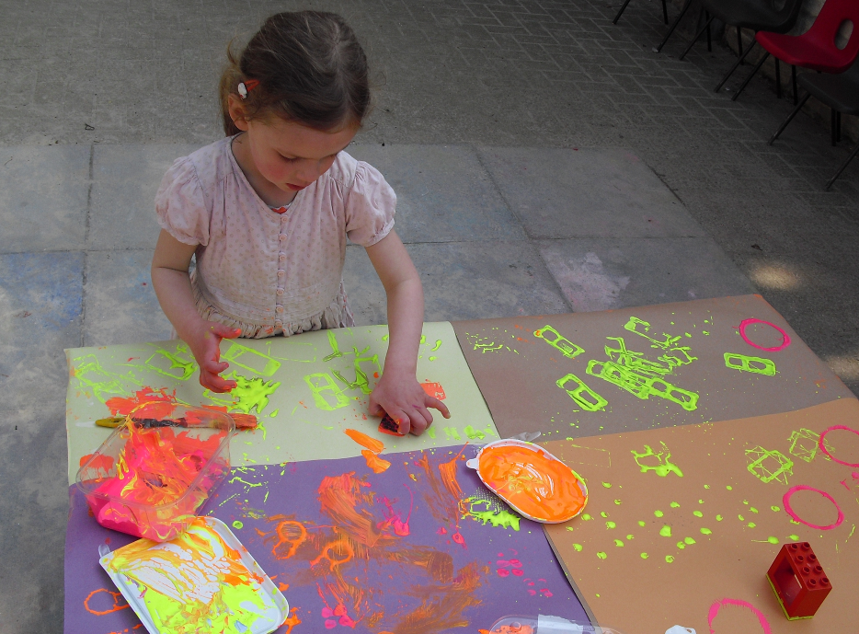

Please contact Natalie Wilson, (Head Teacher), Katherine Bull (Chair of Governors) or Helen Batten (Clerk) via the office for further information:

[headteacher.1006@headington-nurs.oxon.sch.uk](mailto:headteacher.1006@headington-nurs.oxon.sch.uk)

Policies, the prospectus and lots of other information can be found on the website:

http://www.headingtonquarry-nursery.org.uk