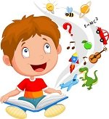
Story Sacks

Trains

Dinosaurs

Elephants
A resource for parents and carers to take home, and share with their child/ren for a short period of time (1-2 weeks).
Sign out a sack from either the main pick up/drop off entrance or the daycare entrance.
What are they? A story sack is a bag containing 3-5 books connected by a theme (e.g. bears, school, numbers or space). Also included are one or more of the following: soft toys, props, puzzles, games etc. relating to one of the stories and/or the theme.
Why use them? They offer a multi-sensory approach to the sharing of books and will make reading fun for both parents and children. Story sacks will help develop and improve your child’s reading skills and encourage a life-long love of reading. By using the sack together, you will provide opportunities for your child to:

Cooking
- Listen to good stories read aloud.
- Talk and extend vocabulary.
- Read for meaning.

New Baby
- Extend general knowledge.
- Develop social skills.
- Improve confidence and stimulate an interest in books and stories.
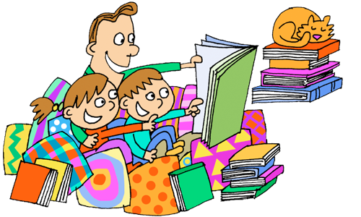
Choose a sack, sign it out, take it home and start exploring!

Transport
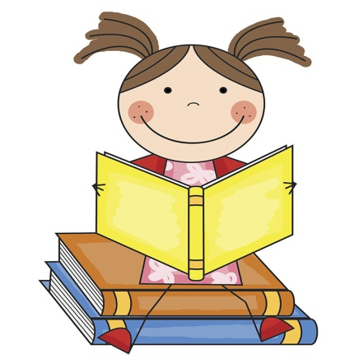

Nature

Feelings

Fish

