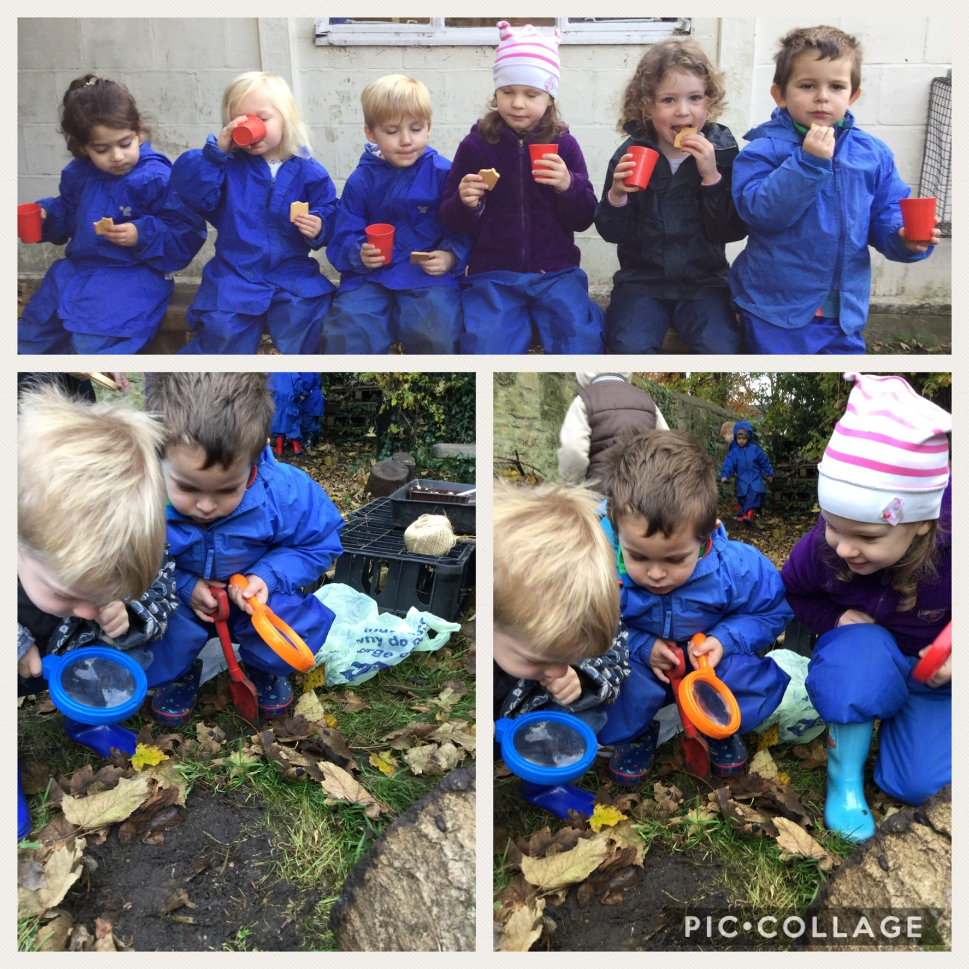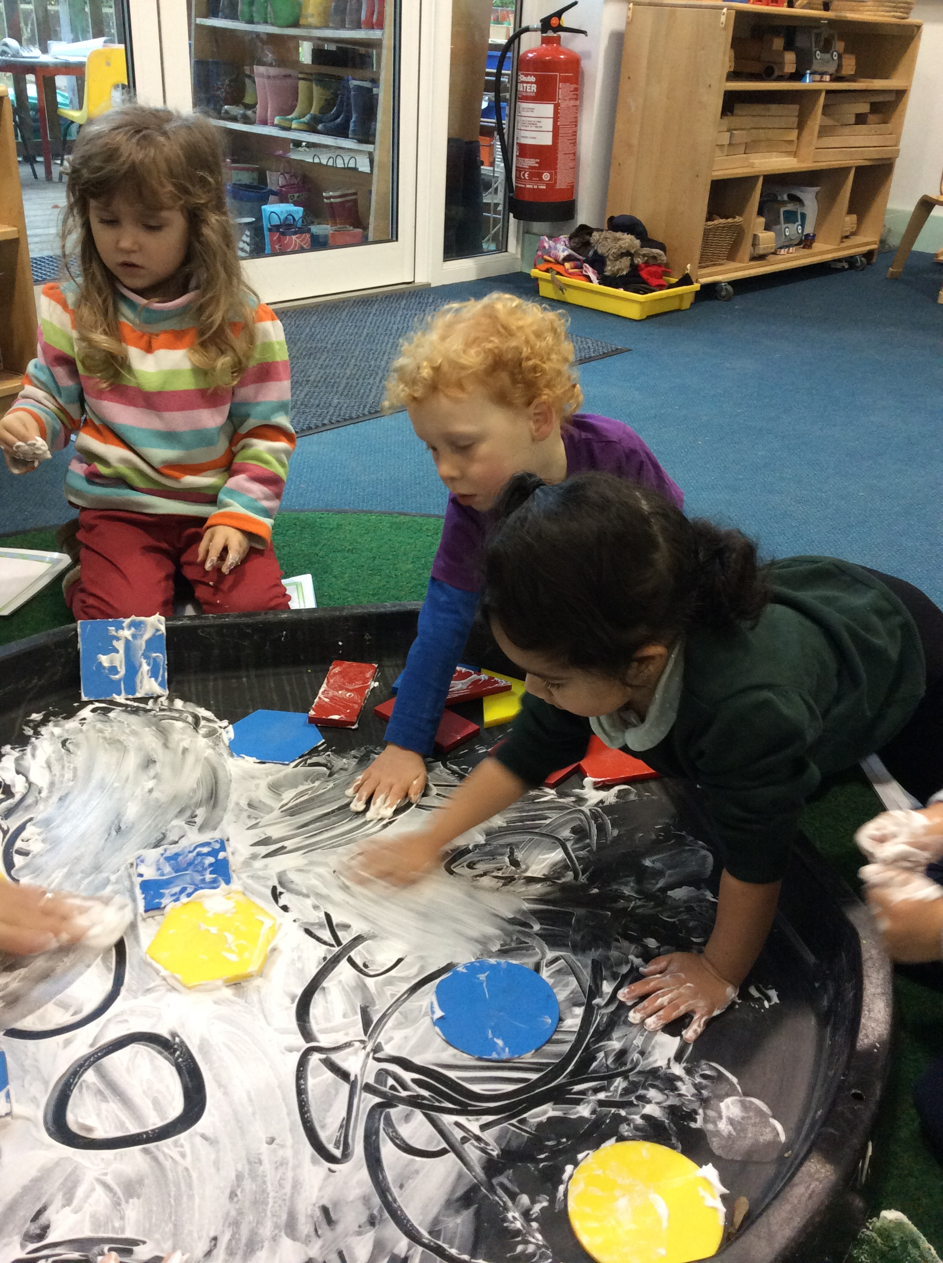

## Dear Parents and Carers,

## This term has flown by and it has been so lovely to see the children grow in confidence and ability in such a short time. The children have made many friends and are now confident with the environment and are accessing the whole learning space.

## For the nursery children Forest School sessions have been happening fortnightly in our wild area. We have started our sessions at school to build up the children’s confidence and understanding of learning outside. We are hoping after Christmas to move onto our new Forest School site in Holy Trinity woodland area. The children have been having lots of fun in their sessions, mud painting, hunting for mini beasts, making dens, whittling and playing in the mud kitchen. For their last session all children will experience cooking marshmallows on the bonfire.

## The Rainbow children have enjoyed a visit to the park where

## they explored signs of Autumn. .

## 

We have two INSET days on the 4th and 5th of January. Holiday daycare will be open on these days if you need to use the service.

Spring Term starts on the 8th January 2018

www.headingtonquarry-nursery.org.uk

Tel/Fax – 01865-762345  
Email – **headteacher.1006@headington-nurs.oxon.sch.uk** Email – **office.1006@headington-nurs.oxon.sch.uk**Email – **daycare.1006@headington-nurs.oxon.sch.uk**

**Quarry School Place Headington, OXFORD  
 OX3 8LH**

30th November 2017

Headington Quarry Foundation Stage School

Autumn 2 Newsletter

‘Where every child is known, valued and respected’.

Inside

Resilience, resourcefulness, reflectiveness.

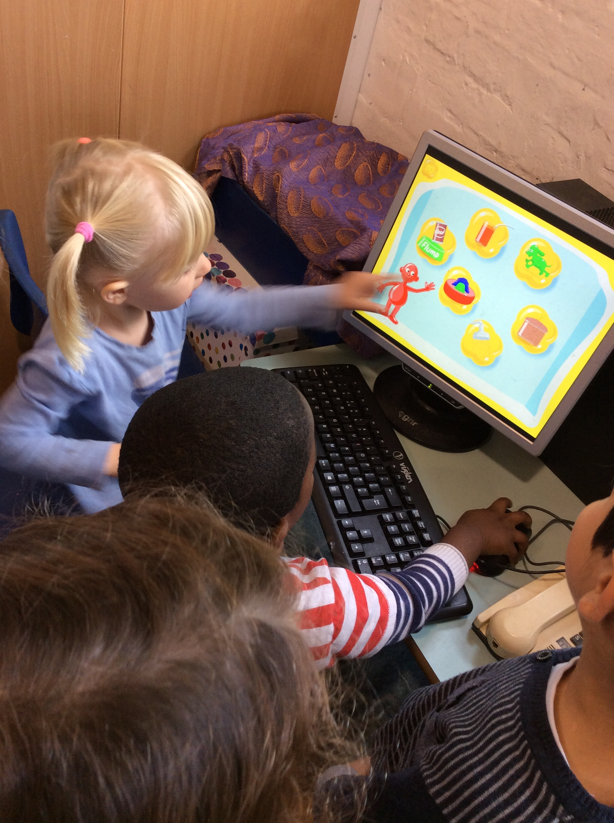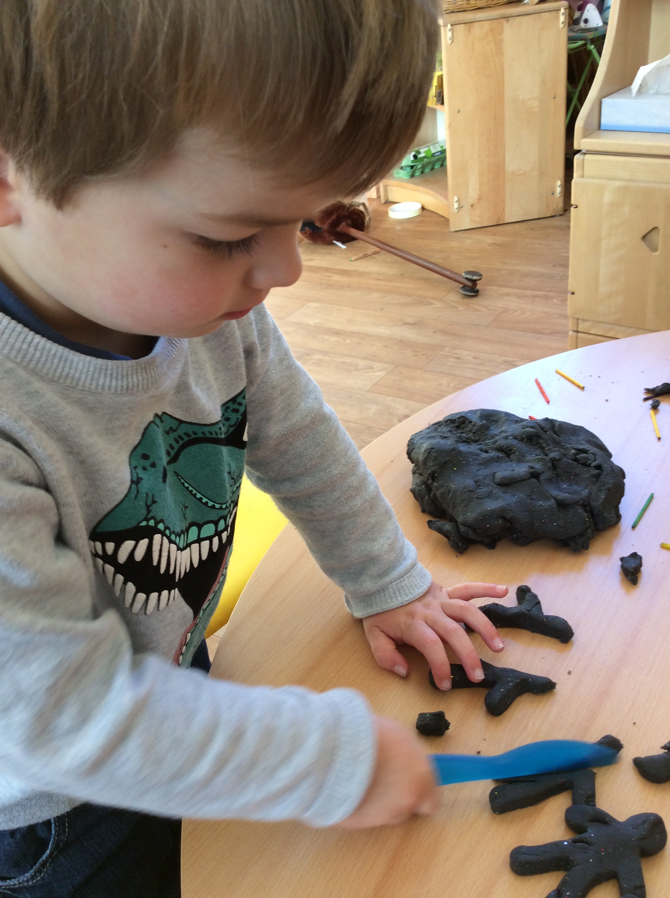

Mobile phones

We do not allow mobile phones to be used on the school site. This is to safeguard the children and families. Thank you for your cooperation with this.

Emails

An email is sent out every Sunday night with information for the nursery families. Please pass on your email if you wish to be part of the mailing list or email Natalie on head.1006@headington-nurs.oxon.sch.uk

Session Times

Please ensure your child is on time for their

session. If your child is consistently

late for group time they are missing out on

learning time and bonding with their group.

It is very unsettling for a child to join a

group in the middle of a session.

Car Parking

I am aware that parking is tight, however

Please ensure you are parking responsibly.

Please ensure you do no park in the staff

car park. Thank you.

Website

Our new website is finally up and running. Please do visit it and hopefully it contains lots of information that you need.

We held an amazing Christmas Fair on Saturday which was supported by so many past and present families. A big thank you to our amazing PTA and all who helped to make it so successful. We raised approximately £1,700, which is an amazing amount for a small school. This money will go to pay for the farm visit in the Spring, living eggs in the Summer and hopefully an interactive whiteboard.

We are very excited to announce the safe arrival of Sarah (butterflies) baby. She had a little girl called Macie on Sunday. We can’t wait to have cuddles.

A huge thank you to everyone for supporting our Children in Need day, we raised £210 for the charity.

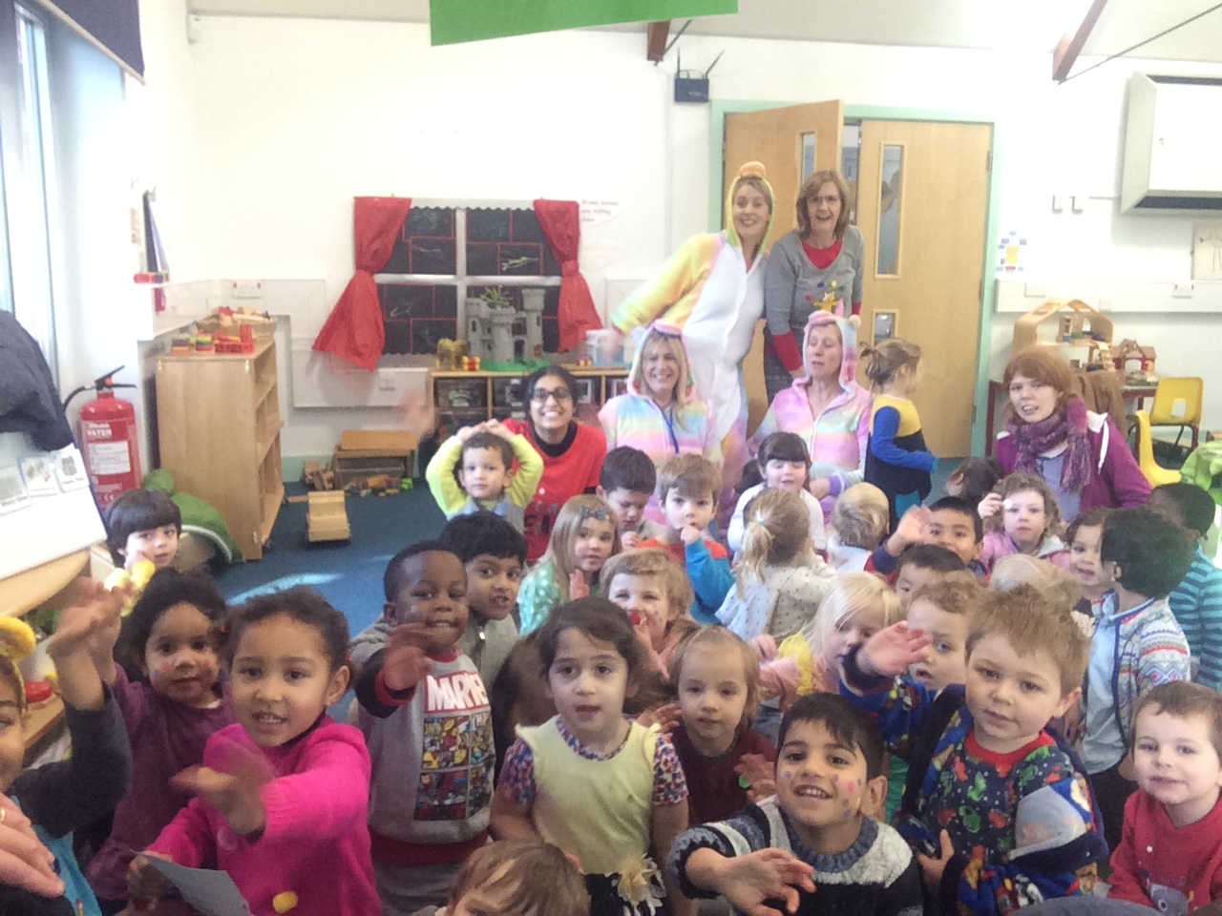

In January we will be welcoming new children and families to school. We will have a new group called the dragonflies, who will be taught by Katherine Cooper. We are very excited that Katherine will be joining us and the she brings many skills to the team.

The children have had great fun following an interest in transport. They have had a visit from a police officer and a bus driver. In the environment they have been role playing doctors, going on a bus and lots of play around babies!

The children have been learning about shapes in the environment, re telling stories especially the three little pigs. With phonic development the children have been listening for environmental and instrumental sounds to tune their ears into distinguishing between sounds, in preparation for segmenting and blending words.

In the New Year we will be moving onto alliteration, rhyming words and oral blending and segmenting the building blocks of phonic development before being introduced to recognition of letter shapes.

Exploratory learning through play

Curiosity, creativity and consideration



Our Christmas show this year is a retelling of the Christian Christmas story. The children have learnt some songs to accompany the retelling and added in a few of our favourites.

Please can you bring in a plain white T –Shirt as soon as possible so we can decorate it for their costume, which they will wear over their normal clothing.

We will be performing in Holy Trinity Church on the 14th at 10.45am and 1.30pm. Your child’s performance time will depend on which session they attend.

If they are an all-day child they will perform in both sessions, so you can chose which performance you come and see.

You will be able to take photographs and video the performance but please be aware of the children’s feelings towards being constantly photographed it can be very off putting. Please also do not share your images on any social media platform for safeguarding reasons.

All gang ways in the Church will need to be clear so please stay in the pews.

It seems very early to be saying this but all the staff wish you a very lovely holiday and restful time. We will look forward to seeing you all in the New Year.

**Dates for your diary:**

Friday 1st December- Rosa and Henna last day

Sunday 3rd December- St Andrews Christmas Fair 11am-3pm

Wednesday 13th December- School Christmas dinner (please book this by Thursday the 7th)

Thursday 14th December- Nursery Christmas Show ‘Shine Star Shine’

Am children 10.45am

Pm children 1.30pm

All day children will be performing in both shows

Friday 15th December – Rainbow trip to the theatre.

Monday 18th December – Rainbow Christmas play times TBC

Tuesday 19th December- Last day of term – fun session

Rainbow children finish at 1.00pm

Spring Term starts on the 8th of January normal times

Last INSET day of the academic year June 4th 2018

**Daycare**

**We have a lovely day care facility run by Kelly. You are able to book for breakfast, after school care or wrap around sessions. You will find the booking forms by the office, with prices on. These sessions need to be booked and paid for the Thursday prior to the week the days are needed, but we are very flexible.**

**Our Christmas holiday daycare we run on 20th,21st and 22nd of December and 4th and 5th January. Please see Kelly or Linda for booking forms.**